**Question D:**

I have an application that displays a list of people through handlebars. I use mongoDB as the database for all my data.

If I go to my /people route I see my list like this:

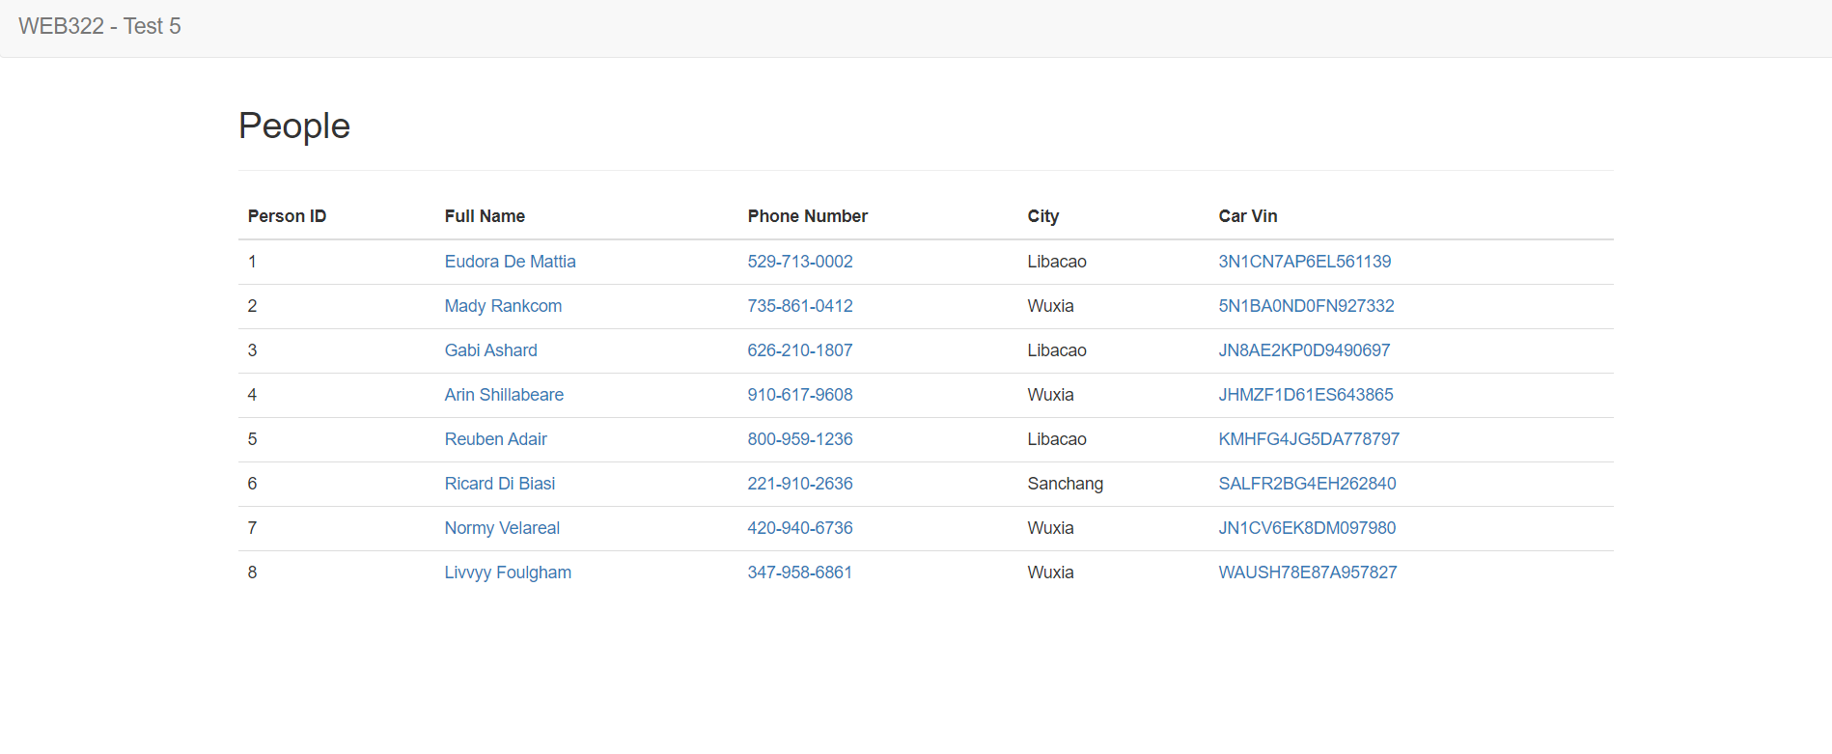

However, when I run a **query by city** (<http://localhost:8080/people?city=Wuxia>) which should return all people in that city I only get this result:

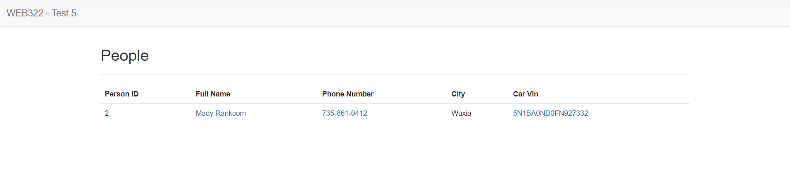

Using the provided handlebars page and code snippets in the test.js

Tell me **what the problem is**, and **how to fix it**.

**Note:** We can assume the server and database are set up correctly and there is no issues with the names of data members.